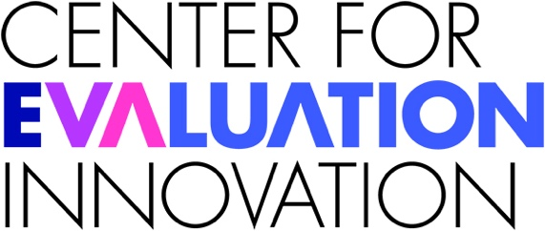

Dr. AnnJanette Rosga
Deputy Director

Dr. AnnJanette Rosga (she/they) is the Deputy Director at the Center for Evaluation Innovation. Dr. Rosga brings over two decades of experience in research, training, and facilitation with organizations dedicated to progressive, systems and social change.

Previously, Anjie co-directed the strategic learning firm, Informing Change. She holds a Ph.D. in the History of Consciousness (interdisciplinary studies), with an emphasis on the cultural study of law, crime, and violence and served as an Assistant Professor of Sociology and Anthropology at Knox College in Illinois and later at the University of Colorado-Boulder.

Prior to her years at Informing Change, Anjie provided research and consulting services for several United Nations agencies (UNDPKO, UNFPA, UNOHCHR, UNDP, and UNICEF) on topics related to post-war peacekeeping, law enforcement, human rights, bias-related violence, human trafficking, and gender and security sector reform. She also directed an international women’s peace NGO with ECOSOC consultative status to the UN Security Council.

Anjie’s past projects have involved strategic planning and evaluation of highly complex initiatives aiming to increase racial and intersectional equity, bring about systems change, affect local, state, or national policy, or build capacity for effective leadership and organizational learning. Her recent clients have included Kresge and Sherwood Foundations, the California State University Student Success Network, The David and Lucille Packard Foundation, ReflectUS, RepresentWomen, The Pew Charitable Trusts, and The Annie E. Casey Foundation.

